Project Planning Phase

SPRINT-1

|  |  |
| --- | --- |
| Date | 4 November 2022 |
| Team ID | PNT2022TMID31875 |
| Project Name | IOT BASED SAFETY GADGET FOR CHILD MONITORING AND NOTIFICATION |

USN 1: As a user I need to enrol the cloud registration

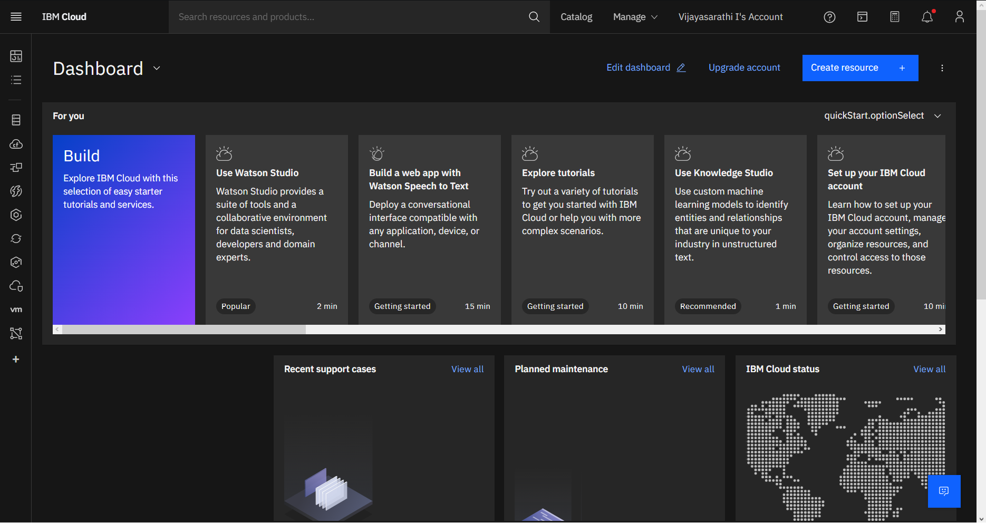

USN 2: After creating cloud account launch IBM Watson IOT platform by accessing cloud account

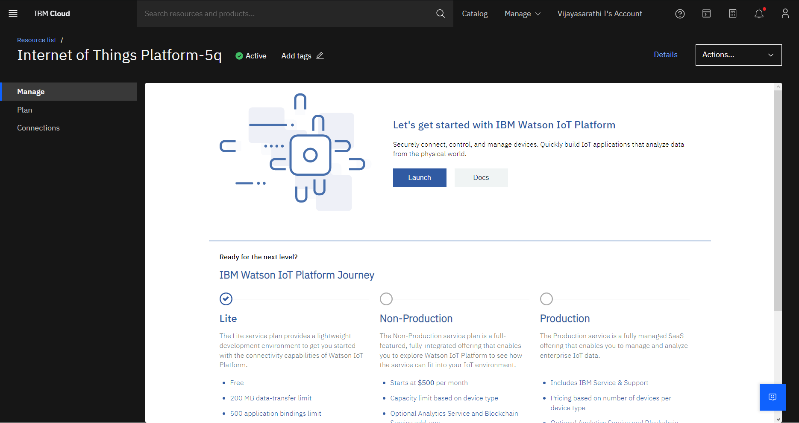

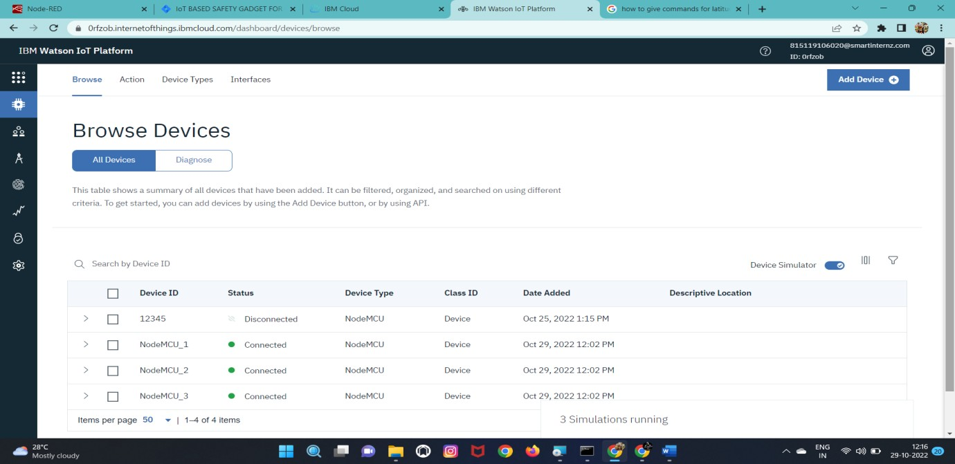USN 3: Create the node in IBM Watson platform

USN 4: After Creating node get device Type and id

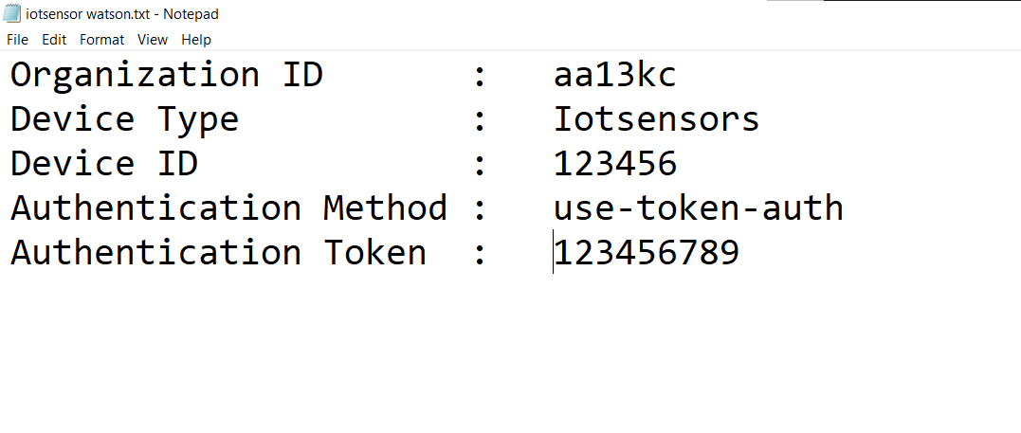

USN 6: Simulate the node created

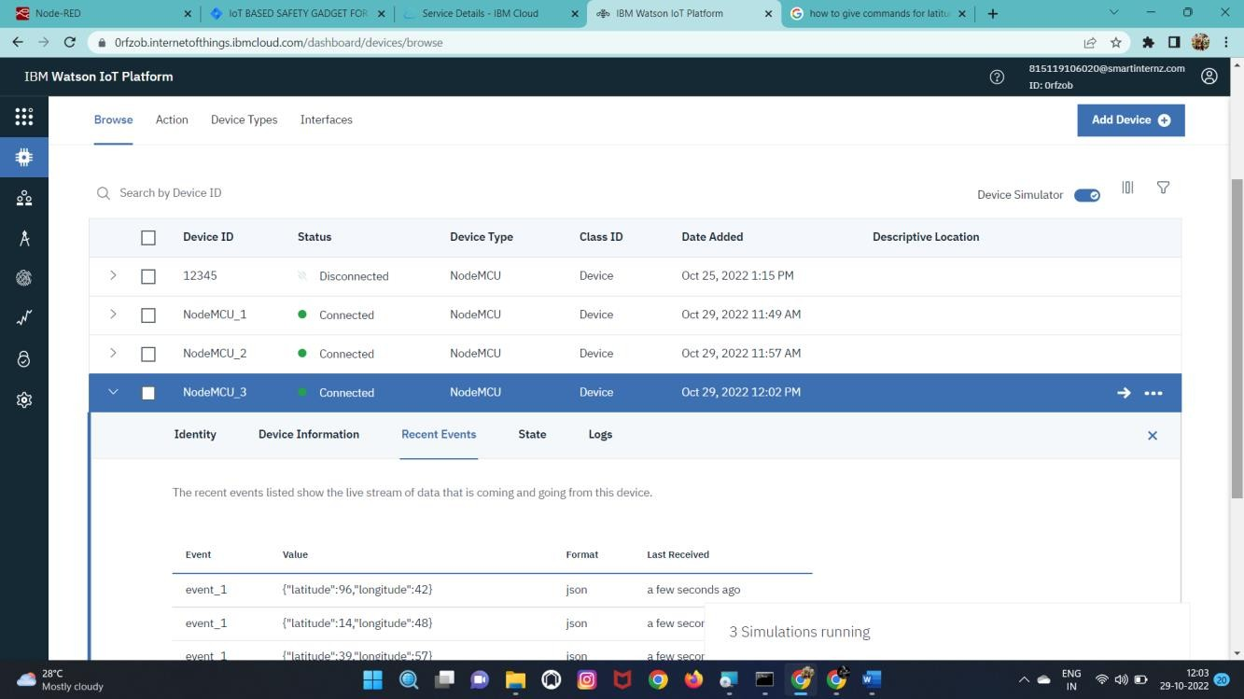

# BURNDOWN CHART:

# 

# VELOCITY CHART:

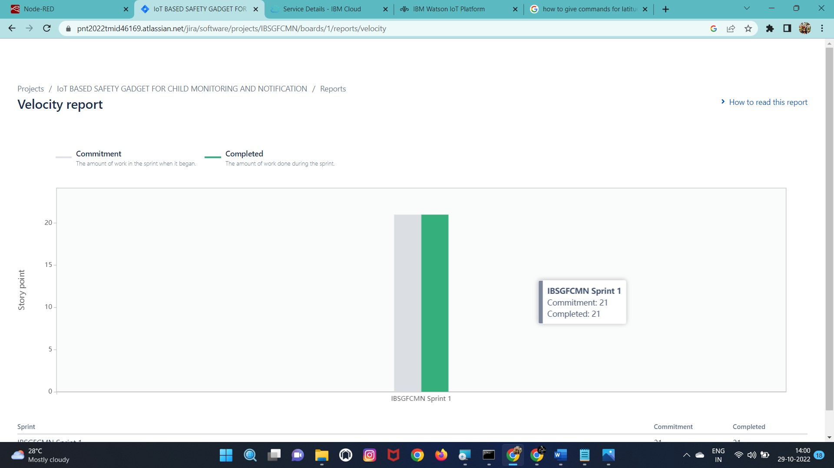

# ROADMAP:

